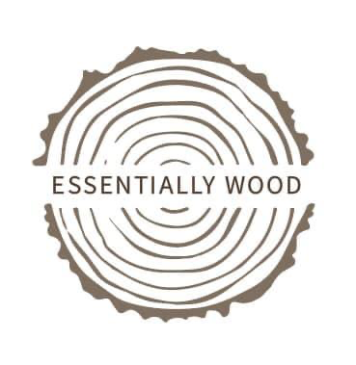
London Plane Wooden Chopping Board care
- Use hot soapy water and cloth and wipe down (on both sides to avoid warping) and dry thoroughly. Leaving a board wet will encourage splitting.
- To remove stains and smells either sprinkle with salt and rub with a cut lemon or rub with bicarbonate soda and a damp cloth.
- Regularly oiling your cutting board will help it last longer. Pour a little oil (make sure it is food safe) on the board, spread it around and let it soak in a while. Wipe excess oil off before storing. Don’t forget to do both sides.
- Oils that can be used; Tung oil, raw linseed (boiled Linseed is not food safe), Coconut oil, walnut oil, bees wax or any ‘Food safe oil’. NB Vegetable oils including Sunflower and Olive oils can become rancid in time
- If you want to sanitise your board, you can apply a small amount of bleach mixed with water, leave it sit and then rinse off. Or you can use straight vinegar instead.

Black stained Oak presentation board care
- Use hot soapy water and a squeezed out cloth (on both sides to avoid warping) and dry thoroughly. Leaving your board wet will encourage splitting.
- To remove stains and smells wipe with a bicarbonate solution
- Regularly oiling your cutting board will help it last longer. Pour a little oil on the board, spread it around and let it soak in a while. Wipe excess oil off before storing. Don’t forget to do both sides.
- Oils that can be used; Tung oil, raw linseed (boiled Linseed is not food safe), Coconut oil, walnut oil, bees wax or any ‘Food safe oil’. NB Vegetable oils including Sunflower and Olive oils can become rancid in time

